

**SLIIT STUDENTS’ ATTITUDES AND PREFERENCES REGARDING FAST FOOD**

FINAL PRESENTATION REPORT

MODULE: IT1080

ENGLISH FOR ACADEMIC PURPOSES

YEAR 1, SEMESTER 2

MLB_WD_CSNE_02.01

|  |  |
| --- | --- |
| **Name** | **Student Registration Number** |
| Silva P. K. A | IT22571298 |
| Chandrasiri E. M. S. M | IT22047656 |
| Lakshitha R. A. T. R | IT22617514 |
| Ravindran S | IT22315700 |
| Weerasekara P. A. S. S | IT22258762 |

# Terms Of Reference

The Sri Lanka Institute of Information Technology's Bachelor of Science (Honors) in Information Technology requires the submission of a report as part of the module IT1080 of year one, second semester.

# Acknowledgement

We are grateful to Ms. Jayavindi Ampemohotti, our esteemed instructor, for helping us complete this project effectively. Her knowledge and experience allowed us to finish the research.

This initiative would not have been a success without the assistance of each and every individual. We were close friends who constantly stood by one another. Additionally, we want to thank everyone else who helped make this effort successful.

# Abstract

The many facets of fast food consumption are examined in this study, with a particular emphasis on the relationship between academic year and age, financial consequences, the effect on student health, customer preferences, and general satisfaction. A representative sample of students is surveyed, questioned, and data analysis is combined with other methodologies as part of the study's mixed-methods approach. The results show that age and the academic year have a big impact on how much fast-food students eat. The study reveals various patterns and behaviors that provide light on how fast-food consumption habits are influenced by factors including workload, time restraints, and lifestyle decisions. The report also looks into the financial effects of eating fast food by examining the prices incurred by such transactions. It outlines the trade-offs students make when selecting fast food as a dining alternative, taking affordability and potential effects on personal finances into account. The study also looks at how fast food affects students' health. It highlights the potential health concerns connected to regular fast-food eating through an examination of nutritional content and available studies. The study emphasizes the value of making well-informed food decisions for students' wellbeing. Consumer preferences are very important when choosing a fast-food restaurant. The study looks into what people value most while choosing between different fast-food options. As important factors, taste, price, convenience, and variety shed light on fast food consumers' top objectives. The survey also explores the most popular justifications for students choosing fast food. The main drivers of fast-food consumption are found to be time restraints, social reasons, and personal preferences. These results contribute to a better understanding of the motivations behind students' fast-food preferences. The survey also evaluates how satisfied pupils are with the fast food they eat. It offers insights into overall satisfaction levels by assessing taste, portion size, service quality, and value for money. The study points up potential areas for fast food business improvement.

This broad review of fast-food consumption among students provides attention on the complex dynamics involving the influence of academic year and age, cost considerations, health issues, consumer preferences, and satisfaction levels. The research provides useful information that can be used by people, decision-makers, and the fast-food sector to encourage better nutritional choices and improve everyone's dining experience.

Table of Contents

Terms Of Reference 2

Acknowledgement 2

Abstract 2

Introduction 5

Methodology 6

1.Data Collection: 6

2.Financial Analysis: 6

3.Health Assessment: 6

4.Consumer Preferences: 6

5.Reasons for Fast Food Consumption: 7

6.Satisfaction Levels: 7

Data Analysis and Discussion 8

1)How the academic year and age affect the consumption of fast food 8

Analysis 8

2)How does eating fast food affect your finances 9

Ways eating fast food can affect you financially. 9

Students monthly cost allocated to fast food. 11

03) How does fast food affect students’ health 11

4) What are the things that people consider most important when they get fast food 14

05) What are the most common reasons for students to eat fast food? 17

6) How Students satisfied with the fast food that they have taken. 20

Conclusion 21

References 23

Appendices 23

# Introduction

Fast food has ingrained itself in our daily lives in today's culture, providing quick and practical meals to fit our hectic schedules. This study intends to explore the many facets of fast-food consumption, with a particular emphasis on its associations with age and academic year, financial ramifications, effects on student health, customer preferences, and general satisfaction. We will first look at how age and the academic year affect fast food intake. We can learn more about how students' eating habits are influenced by their lifestyle decisions, timetable restrictions, and academic workload by observing their patterns and actions. We will then talk about the financial effects of eating fast food. We can better comprehend the effects of fast food on personal finances and budget management by looking at the expenditures related to these transactions. The potential compromises people may make when choosing fast food as a meal alternative will be discussed in this section. We’ll also look at how fast food affects students' health. We can evaluate the impact of fast-food intake on students' wellbeing and general health by considering its nutritional features and potential health hazards. This investigation will contribute to increasing awareness of the significance of making wise food decisions. We’ll also investigate what factors people think are most crucial when selecting a fast-food restaurant. We can learn more about consumer preferences and priorities by identifying important factors like flavor, price, convenience, and diversity. In addition, we'll look at the most typical explanations for why students favor fast food as their preferred eating option. The fundamental reasons why students choose to eat fast food, such as time restraints, societal pressures, and personal preferences, will be discussed in this section. Finally, we will evaluate the extent to which students are satisfied with the fast food they eat. We can assess the general levels of satisfaction and highlight areas that may benefit from improvement by looking at elements like flavor, portion size, service quality, and value for money.

This paper seeks to offer a thorough understanding of the consumption of fast food and its ramifications through an in-depth analysis of these subtopics. Insights into the complexities and dynamics of fast-food decisions can be gained by looking at a variety of factors, allowing for more educated choice-making and encouraging healthier lifestyles.

# Methodology

## 1.Data Collection:

Conduct surveys or questionnaires to gather primary data from a representative sample of students across different academic years and age groups. Include questions related to fast food consumption habits, preferences, reasons for choosing fast food, and satisfaction levels. Collect data on academic year, age, and demographic information to analyze correlations.

## 2.Financial Analysis:

Gather data on the costs of fast-food items from various fast-food chains. Analyze individual spending habits by reviewing personal financial records or conducting interviews. Compare the costs of fast food with alternative meal options, such as cooking at home or dining in a restaurant.

## 3.Health Assessment:

* + Review existing research studies and literature on the health effects of fast-food consumption.

• Gather information on the nutritional value of popular fast-food items.

• Examine the possible health consequences of consuming fast food while considering elements like calorie intake, fat content, and sodium levels.

## 4.Consumer Preferences:

* + Conduct surveys or interviews to understand the factors that individuals consider most important when choosing fast food.
  + Include questions about taste, price, convenience, variety, and other relevant factors.
  + Analyze the responses to identify the key considerations and priorities of fast-food consumers.

## 5.Reasons for Fast Food Consumption:

* + Conduct qualitative interviews or focus groups with students to explore their motivations for choosing fast food.
  + Explore factors such as time constraints, social influence, advertising, and personal preferences.
  + Analyze the qualitative data to identify common themes and patterns.

## 6.Satisfaction Levels:

* Use a rating scale or Likert-type questions in surveys to measure satisfaction with fast food.
* Gather feedback on taste, portion size, service quality, and value for money.
* Analyze the survey responses to determine the overall satisfaction levels among students.

# 

# Data Analysis and Discussion

# 1)How the academic year and age affect the consumption of fast food

As students’ progress through different academic years, their schedules, workload, and priorities often change. Likewise, age can influence individual preferences and responsibilities. These factors may significantly influence the consumption of fast food among Sri Lanka Institute of Information Technology students.

## A picture containing text, screenshot, diagram, line Description automatically generated Analysis

Figure 1

The graph (Figure1) compares the eating habits of SLIIT students across different academic years, specifically their frequency of consuming fast food. The Y-axis represents the number of students, categorized as those who choose fast food once per week, two to three times per week, or throughout the entire week. The academic year is represented by the X-axis. First-year students are more likely than other students to be seen eating fast food once or twice per week, compared to two to three times per week for first-year students. The graph also shows that only first-year students consume fast food more frequently than fourth-year students once a week across all the groupings.

The graph also shows that second- and third-year students tend to eat fast food less frequently, while first-year students typically prefer it throughout the entire week.

The findings show that a sizeable percentage of students eat fast food every day of the week, and a sizeable percentage eat it twice to three times each week. On the other hand, less students only eat fast food once a week.Top of Form

# 2)How does eating fast food affect your finances

People consume a wide range of cuisines, and in contemporary culture, fast food has grown immensely popular with the general population. Meals that are prepared and served swiftly are known as fast food. It goes for in several locations, including restaurants, hotels, canteens, and street vendors. Fast food is frequently seen to be a low-cost option, but it's important to remember that fast food restaurants make large profits from their sales, which shows how well-liked fast food is. While there are advantages of fast food, there are also disadvantages to take into account. Numerous factors might increase the cost of fast food

## Ways eating fast food can affect you financially.

* **Cost of fast food**

Fast food can be reasonably priced, but expenses can quickly mount. If you eat fast food frequently, the cost might add up over time to be a sizable outlay. It's crucial to take into account how much more expensive fast food is than home cooking.

* **Health costs**

Obesity, diabetes, and heart disease can all be caused by eating fast food too frequently. High medical costs could be a result of these medical issues, which would be disastrous for your financially.

* **Cost of productivity**

Eating unhealthy fast food also affects your productivity. After consuming high-calorie fast food, you could feel drowsy and exhausted, which could affect your productivity at work.

**AnalysisForms response chart. Question title: Have fast-food become a basic need for you?

. Number of responses: 80 responses.**

Figure

The above pie chart (Figure2) displays 80 students at SLIIT campus, how to respond, “Have fast-food become a basic need for you?” question. The findings indicate that a significant portion of students saw fast food as a need in their everyday lives. Only less of students, indicated that fast food had taken the place of other dietary mainstays for them. Fast food is still a substantial part of the diets of more than a quarter of the survey participants' peers, who admitted to eating it periodically. Less pupils (43.75%) said they did not have a fundamental need for fast food. Overall, the survey's results show that many SLIIT campus students view fast food as a necessity and that it has a significant impact on their lives. A large portion of college students typically include fast food in their daily diets. Therefore, they spend a significant amount of money on fast food in a month.

## Students monthly cost allocated to fast food.

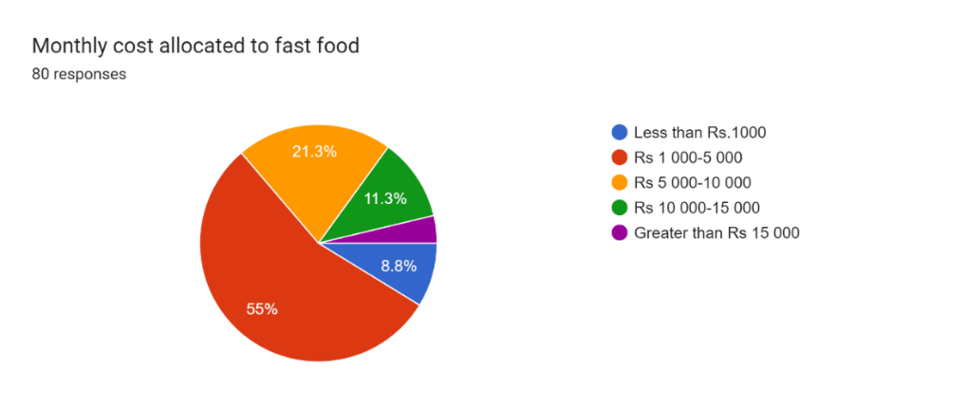

Figure

Based on the survey results of SLIIT campus students (Figure3), it can be concluded that a significant proportion of students spend a considerable amount of money on fast food each month. The majority of students said they spent between Rs. 1,000 and Rs. 5,000 on fast food, and 21.3% said they spent between Rs. 5,000 and Rs. 10,000. A comparatively small fraction of students, however, spend less than Rs. 1,000 on fast food each month, and even fewer spend between Rs. 10,000 and Rs. 15,000 or more.. These findings suggest that fast food is a significant expenditure for a considerable proportion of SLIIT campus students.

In conclusion, eating fast food frequently can hurt your budget in a number of ways, including increased food prices, health costs, and decreased productivity..

# 03) How does fast food affect students’ health

The goal of this study is to investigate the links between eating fast food and health outcomes.

* **What are the health conditions that fast food have negative impact?**

Different foods can affect everyone in different ways. There are diseases that fast food can affect and also some diseases caused by fast food. such as,

Dental problems

Obesity

Depression

Digestive issues

Heart disease and stroke

Type 2 diabetes

Certain types of Cancer

Shortness of breath

* **How does fast food affect health?**

There is a chance that eating fast food is unhealthy. Some of the immediate effects include narrowed arteries, elevated blood pressure, constipation, and indigestion. When fast food consumption gets twice weekly, it raises the risk of type 2 diabetes, metabolic syndrome, coronary heart disease, and obesity. Some particular health implications of eating fast food include increased blood pressure, an increased risk of heart disease since eating fried foods takes cholesterol levels, and weight gain as a result of eating high-calorie, processed carbohydrate-rich items. Due to blood sugar rising and decreases, fast meals can also deplete your energy.

* **Analyze**

Figure 4

The above pie chart(Figure4) shows the SLIIT student’s responses regarding the awareness of the illnesses linked to eating fast food.

First, the majority of students (nearly two thirds) choose the "Sometimes" response because they are aware of the illness before consuming fast food. Less students select the "Always" response, and a significant number selects the "Not at All" response because they are unaware of the illness associated with fast food. Finally, one in ten students selects the "Most of the Time" response. Following research, this pie chart reveals that approximately just over a three quarter of the students are aware of the sickness associated with consuming fast food.

Figure 5

The illness of SLIIT students is depicted in the pie chart above. Most students do not have any illnesses, and there are fewer students with diabetes on the pie chart. (Figure5).

First, nearly more than one-third of students, a sizeable portion, suffer gastritis. More than one in ten pupils are obese, and one in twenty students have heart disease.

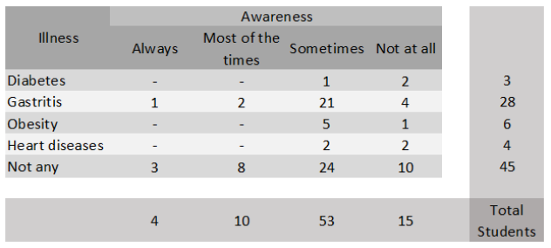

Table

In the table (Table1) above shows the illnesses that SLIIT students experience are compared with the illnesses that are associated with eating fast food. Student illnesses are shown in rows, and illnesses related to eating fast food are shown in columns. Among the 41 students who already have the aforementioned health conditions, 32 are aware that fast food is a contributing factor to their illnesses. While the other 9 students do not aware of those illnesses linked to eating fast food. The remaining 35 kids are at least partly aware of these ailments, compared to ten students who do not have any of these disorders.

# 4) What are the things that people consider most important when they get fast food

We wanted to demonstrate what factors SLIIT students take into consideration when they eat fast food, so we divided it into several categories, including taste, appearance, brand, price, location, ingredients, and nutrition. In the following presentation, we analyzed these categories using the information we gathered from the questionnaire and articles connected to these topics.[04]

If we analyze it separately, we can compare each topic with the age, study year and with gender.

* **Tastiness**

When consumers decide to eat fast food For many people, taste is still important. Based on personal preferences and cultural conditions, there are numerous conventional terms and expressions that are used to describe how tasty a food is. In fact, the flavor of fast food is typically a defining characteristic of the industry, with businesses attempting to provide customers the most appetizing and enjoyable options. The deliciousness of fast food cannot be disregarded in this fast-paced age.

* **The look**

In the fast food industry, the way a dish looks is important since it can have a big impact on how a customer feels about its quality and freshness. Fast food companies devote a lot of effort and resources to developing aesthetically pleasant menus and packaging because they value looks.

* **The Brand**

In the fast food market, a company's brand is essential since it influences customer perception, loyalty, and overall performance. To set themselves apart from the competitors and attract customers, fast food companies spend a lot of money developing and promoting their brands.

* .**Price**

The price given how important it is for bringing customers in and changing their purchase choices, the cost of fast food is a crucial element in the market.. Fast food establishments understand how crucial it is to offer competitive pricing that appeals to a wide range of customers while still being profitable

* **Location**

Fast food restaurants choose their locations with care to make sure that their target market can readily find and see them. Because it determines how many people and how much money a fast food establishment may bring in, location is essential to its success. Overall, fast food restaurants' success in the sector depends heavily on where they are located. Fast food franchises may draw customers, increase revenue, and develop a devoted following by carefully choosing sites that are easily accessible, prominent, situated in regions with heavy traffic and a broad client base. [04.2]

* **Ingredients and nutritional**

For many customers who are increasingly health-conscious and worried about the quality of their meals, the ingredients and nutritional content of fast food are crucial factors to take into account. A lot of fast food restaurants have changed their menus to accommodate shifting consumer needs because they recognize how important it is to offer tasty and healthful menu options.. [04.1]

* **Is it necessary to have any details when people eat fast food?**

When it comes to fast food, it is crucial to take the food's specifics into account. Customers can enjoy fast food while still eating a healthy and balanced diet by making educated decisions and paying attention to aspects like nutritional information, ingredient quality, and overall customer experience.

Figure 6

The graph contrasts (Figure 6) the things that SLIIT students take into consideration when choosing fast food. The Y axis indicates the measuring unit, which is the number of persons that agree, disagree, or are neutral, while the X axis shows the components. The majority of students consider the testiness and that no students disagree with it, while just a tiny percentage of students don't take any concerns into consideration when they buy fast food.

After taste, however, price indicates that many students pay attention when they buy fast food, and a sizable number of students also take location and appearance into consideration. Among all the variables, they are expressing less interest in the brand, the components, and the nutritional.

Most students are displaying their lack of interest in the brand, the ingredients, and the nutrient content, while a smaller percentage are uninterested in how it looks and the location. Students can't resist considering the price, and the graph above demonstrates that a substantial number of respondents agree with it while others express no opinion. The data indicates that most students are considering the considerations, while a small number are not interested.

# 05) What are the most common reasons for students to eat fast food?

Some of us may love fast-food while others may be hated it but there are many reasons why most people consume fast food now a days Fast food is a presence in almost everybody’s life daily basis Over a quarter of American adults eats fast food daily. Changes in everyone’s lifestyle and loss of family these reasons popularity of fast foods among young people consumes it. Now a days, the habit of consuming fast food has increased among university students. Most universities are surrounded by fast food restaurants as most students prefer fast food. To know more about this, we designed a survey to find out the reasons why our students choose fast food. [05.1]

Following are the reasons we hypothesized for SLIIT university students consuming fast food, they are quick (Service), They are inexpensive, Like the taste, offers a variety, Busy to cook, Convenient, socializing with friends/family and Inspired by Advertising. [05.2],[05]

* **They are quick.**

And fast food is done almost instantly. As a result, the simplest solutions come by way of fast food, allowing an easiest and very quick meal.

* **They are inexpensive.**

In general, such a statement is accurate. Fast food is frequently more affordable than other sorts of cuisine, like sit-down restaurant meals or meals prepared at home.

* **Like the taste .**

The taste of fast food is popular. Many people find the cuisine to taste highly appetizing because they frequently utilize a lot of salt, sugar, and fat in their dishes.

* **Offers a variety.**

Absolutely fast-food establishments frequently provide a wide range of meal selections to accommodate various tastes and preferences. Fast food is a popular option because of the variety of options available.

* **Busy to cook.**

People frequently choose fast food since they have a hectic schedule and don't have time to prepare meals at home. Fast food is a simple option for people who don't have time to prepare a meal from scratch because it is frequently accessible for quick and convenient takeaway or delivery.

* **Convenient**

Yes, because it is quick and simple to obtain, fast food is frequently regarded as convenient.

* **Socialize with friends and family.**

Yes, going to fast food places is frequently done so that people can socialize with their friends and family. Without the requirement for a formal reservation or a dress code, fast food restaurants provide a casual and relaxed setting where people may congregate and enjoy a meal together.

* **Inspired by advertising.**

It is true that advertising can have an impact on how people decide what to eat, including whether they prefer fast food. Fast food chains spend a lot of money on advertising to build their brands, market their goods, and persuade customers to select their food over that of their rivals.

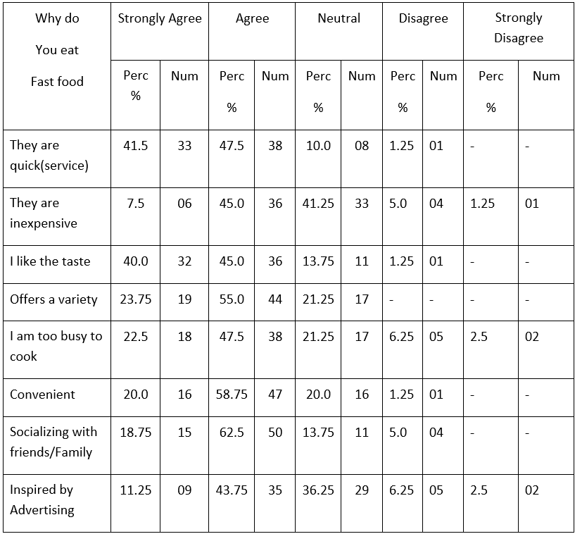Forms response chart. Question title: Why do you eat fast food?
. Number of responses: .

Table 2

Figure 7

This chart (Figure 6) indicates why they choose fast food. Many students agree that they eat fast food for all the reasons we have given.62.5% (n = 50) (Table 2) of them agree that socializing with friends and family is the most important reason for consuming fast food. Others strongly agree (n = 15) (p = 18.75%) with this statement. 1.25% of the students (n = 1) disagree that they could not get fast food on time. 41.25% (n = 33) of students gave the neutral response of "they are inexpensive. Most of the students (99.0%) (Table 01) agree that they choose fast food based on its taste.11.25%(n=09) of the students strongly agree, and 43.75%(n=35) of the students agree they are eating fast food by looking at the advertisement. 36.25% (n=29) of the students’ neutral response to this reason 6.25%(n=05) of the students disagree, and 2.5%(n=02) of the students strongly disagree with the statement that they are inspired by advertising. 55.0% (n = 44) of the students agree that they choose fast food because it offers a variety of foods. 58.75% (n = 47) of the students agree that fast foods are very convenient to them.

# 6) How Students satisfied with the fast food that they have taken.

Understanding university students' attitudes and behaviors about fast food can depend in large part on how satisfied they are with the fast food they eat. Fast food is enticing since university students are frequently busy and may not have the means or time to prepare meals from scratch. Researchers may utilize surveys, questionnaires, or interviews to acquire information from students in order to gauge how satisfied they are with fast food. Gaining insight into the level of satisfaction that this demographic has with fast food can help fast food establishments make improvements to their menus and give this market a more gratifying experience.

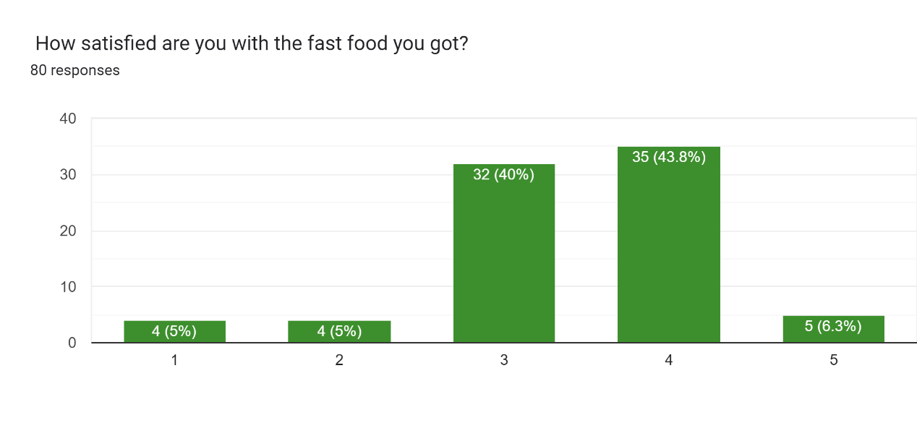

Figure 8

In this chart (Figure 8), it shows how satisfied our university students are with the fast food they got. 5% of the students (n = 4) were not satisfied with the fast food they got. 40% of the students (n = 32) were neutrally satisfied that they were consuming fast food. 43.8% of the students (n = 35) are more than 80% satisfied with fast food. 6.3% of the students (n = 5) confirmed that they get 100% satisfaction from the fast food they eat.

# Conclusion

In conclusion, fast food is a well-liked and practical cuisine type that has grown to be a sizable portion of the world food market. While it provides rapid and simple access to food, when consumed frequently and in big amounts, it can have detrimental effects on health. Making informed food decisions and looking for healthier options whenever possible are therefore crucial. According to the research SLIIT students are more likely than peers without a degree to eat fast food. This is probably due to factors like expense, convenience, and time. Additionally, first-year university students are more likely to consume fast food compared to those in their second year.. In conclusion, age, university, and academic year can all affect how much fast food is consumed. Due to convenience, expense, and time restraints, SLIIT students, especially those in their first years and second years, may be more prone to eat fast food.

As a result of the survey’s analysis, it can be concluded that a large number of SLIIT campus students place a high value on fast food .A sizable portion of students ,compared to a smaller portion who do not, view food as a necessity in their everyday lives .This indicates that a lot of students include fast food in their diets and allot a sizeable percentage of their monthly budget to cover these cost.

The survey results also bring attention to the financial costs of frequent fast-food consumption. The price of fast food can add up quickly over time and become a significant expense when compared to cooking at home. Additionally, eating too much fast food can lead to health problems including obesity, heart disease, and diabetes, all of which can raise medical expenses. Consuming unhealthy fast food can also reduce productivity, which could have an impact on earnings and overall financial wellbeing.. Making healthier meal choices and cooking at home more frequently is advised for people given the financial repercussions of relying largely on fast food. They may eventually be able to improve their overall financial stability, retain better health, and save money by doing this.In conclusion, the majority of our SLIIT students are satisfied with fast food. figuring out how satisfied college students are with fast food is a crucial part of understanding their attitudes and behaviors in relation to it. University students frequently use fast food as a quick and inexpensive meal option because they are busy people with little time and money. In order to give university students a satisfactory experience, fast food establishments must focus on the quality and flavor of their offerings in addition to giving convenient and economical meals.

# References

* <https://money.usnews.com/money/personal-finance/articles/is-fast-food-cheaper-than-cooking-at-home> (r1)
* <https://health.clevelandclinic.org/heres-how-fast-food-can-affect-your-body/> (r2)
* <https://www.foodnavigator.com/Article/2015/01/27/Unhealthy-food-is-tastier-Is-it-possible-to-change-this-belief> (r3)
* <https://health.clevelandclinic.org/heres-how-fast-food-can-affect-your-body/> (r4)
* <https://www.medicalnewstoday.com/articles/324847> (r5)
* <https://www.eatthis.com/healthiest-fast-food-restaurants/> (r6)
* <https://www.bbc.com/future/article/20211206-does-seeing-food-on-social-media-make-us-eat-more> (r7)
* <https://web.colby.edu/st297-global18/2018/10/29/americas-fast-food-obsession/> (r8)
* <https://www.society19.com/reasons-why-people-choose-to-eat-fast-food/amp/> (r9)

# Appendices